**FUNCTIONAL AND TECHNICAL COMBINED DOCUMENTATION**

**Page (12): Fixed Income Portfolio—My Holdings (Front End Url:** http://localhost:8100/page12/Page12)

**Functional Picture:**

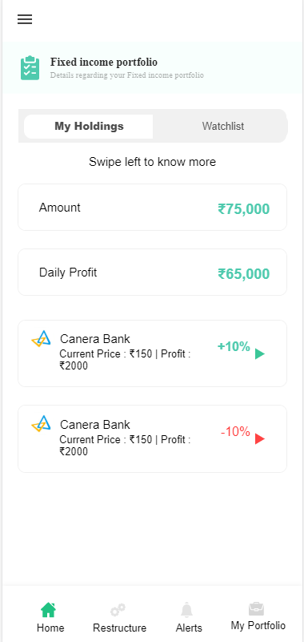

**In this Page, the user is going to see the list of fixed income securities that the user has in his portfolio along with Amount and the daily profit of his/her holding.**

**Technical Explanation (Front End and Back End):**

**In Page12.tsx, we are calling following 1 API:**

1. MyHoldingDisplayAPIFI: see backend python file. In this we are doing GET requests.

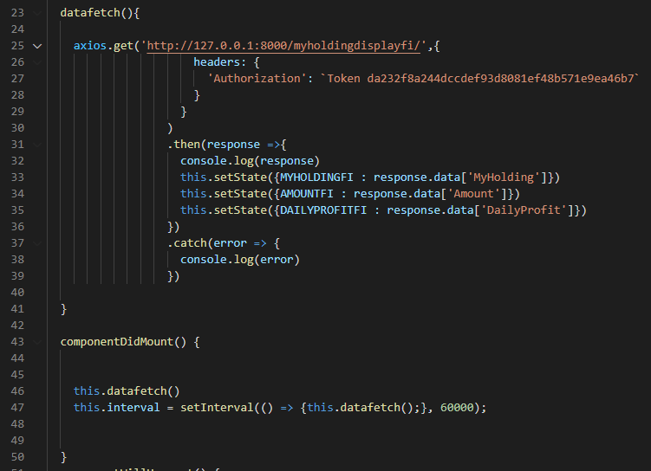

**As you can see, we are calling the** MyHoldingDisplayAPIFI

**using this url:** [**http://127.0.0.1:8000/myholdingdisplayfi/**](http://127.0.0.1:8000/myholdingdisplayfi/)**. In this we are taking my holding list along with the total amount invested on that holdings and the daily profit.**

**Kindly see the given below backend Code for this GET request.**

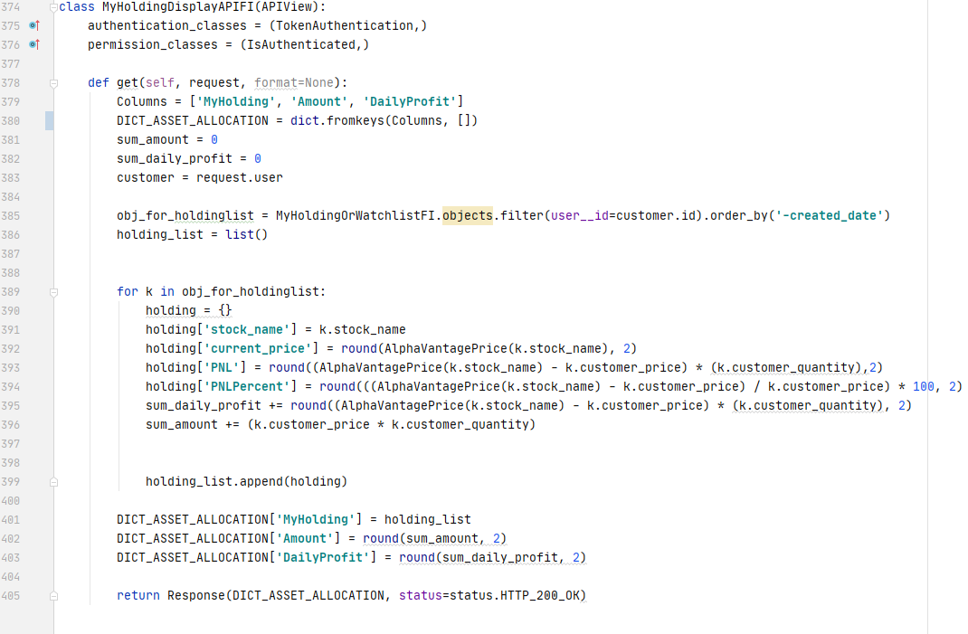

**Here Amount is calculated as (sum(customer_price(i.e., the price at which the customer bought the fixed income) * quantity)**

**Daily profit =( current_price – price_at_which_the_fixed income_was_bought) * quanttity.**

**Inside Holding List, we have the following attributes:**

1. **Fixed income name**
2. **Current price**
3. **PNL**
4. **PNL Percent**

**Here we are using MyHoldingOrWatchListFI database.**

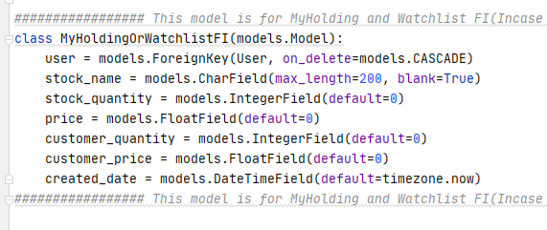

**DONE!!!**